Assignment-6

import numpy as np

import pandas as pd

import matplotlib.pyplot as plt

import seaborn as sns

df = pd.read_csv("Iris.csv")

df.head()

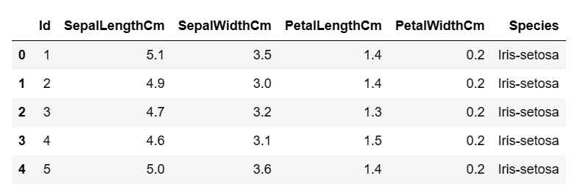

df['Species'].unique()

ouput: array(['Iris-setosa', 'Iris-versicolor', 'Iris-virginica'], dtype=object)

df.drop(columns="Id",inplace=True)

df.isnull().sum()

output: SepalLengthCm 0

SepalWidthCm 0

PetalLengthCm 0

PetalWidthCm 0

Species 0

dtype: int64

X=df.iloc[:,0:4].values

y=df.iloc[:,4].values

from sklearn.preprocessing import LabelEncoder

le = LabelEncoder()

y = le.fit_transform(y)

from sklearn.metrics import make_scorer, accuracy_score,precision_score

from sklearn.metrics import classification_report

from sklearn.metrics import confusion_matrix

from sklearn.metrics import accuracy_score ,precision_score,recall_score,f1_score

#Model Select

from sklearn.model_selection import KFold,train_test_split,cross_val_score

from sklearn.naive_bayes import GaussianNB

X_train,X_test,y_train,y_test=train_test_split(X,y,test_size=0.3,random_state=0)

gaussian = GaussianNB()

gaussian.fit(X_train, y_train)

Y_pred = gaussian.predict(X_test)

accuracy_nb=round(accuracy_score(y_test,Y_pred)* 100, 2)

acc_gaussian = round(gaussian.score(X_train, y_train) * 100, 2)

cm = confusion_matrix(y_test, Y_pred)

accuracy = accuracy_score(y_test,Y_pred)

precision =precision_score(y_test, Y_pred,average='micro')

recall = recall_score(y_test, Y_pred,average='micro')

f1 = f1_score(y_test,Y_pred,average='micro')

print('Confusion matrix for Naive Bayes\n',cm)

print('accuracy_Naive Bayes: %.3f' %accuracy)

print('precision_Naive Bayes: %.3f' %precision)

print('recall_Naive Bayes: %.3f' %recall)

print('f1-score_Naive Bayes : %.3f' %f1)

output: Confusion matrix for Naive Bayes

[[16 0 0]

[ 0 18 0]

[ 0 0 11]]

accuracy_Naive Bayes: 1.000

precision_Naive Bayes: 1.000

recall_Naive Bayes: 1.000

f1-score_Naive Bayes : 1.000